Unit: LEVITON CAT6 eXtream

Room: Telecom Room PreK

Floor: Basement

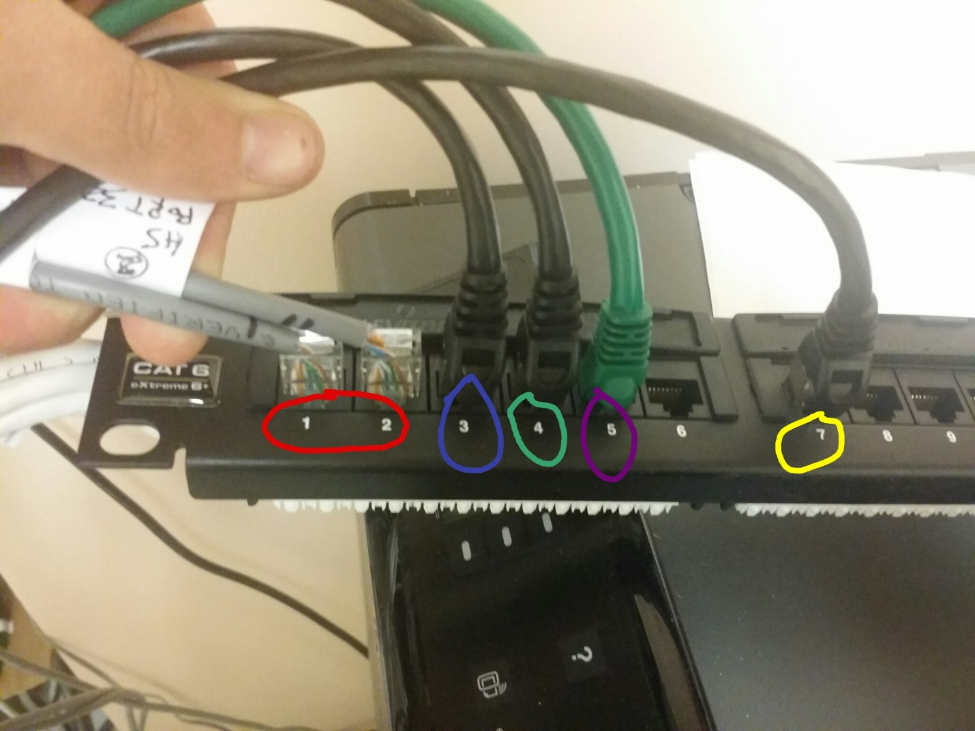

|  |  |  |  |  |  |
| --- | --- | --- | --- | --- | --- |
| Port Number | Network | IP Address | Role | Source | Destination |
| 1 + 2 | Phone System |  |  |  |  |
| 3 | High School LAN | 192.168.30.000 | Middle Man | Sonic Wall TZ 200 X3 | TP-Link 24 PS High School Class X24 |
| 4 | Lab LAN | 192.168.40.000 | Middle Man | Sonic wall TZ 200 X4 | TP-Link 24 PS Lab X24 |
| 5 | PreK LAN | 192.168.20.000 | Middle Man | SW TZ200 X2 VIA TP 24 PS Telcom PreK | Server X2 |
| 7 | Modem | DHCP Public IP | Middle Man | Modem X4 | Server X1 |